

RAFFLES INSTITUTION
PRELIMINARY EXAMINATION 2010

Higher 2

CHEMISTRY 9647/03, 9746/03

Paper 3 Free Response 13 September 2010

Candidates answer on separate paper. 2 hours

Additional Materials: Writing Paper
Data Booklet

READ THESE INSTRUCTIONS FIRST

DO NOT open this question booklet until you are told to do so.

Write your name, class and index number in the spaces provided on the cover page.
Write in dark blue or black pen on both sides of paper.
You may use a soft pencil for any diagrams, graphs or rough working.
Do not use staples, paper clips, highlighters, glue or correction fluid.

Answer any four questions.
Begin each question on a fresh sheet of paper.
A Data Booklet is provided. Do not write anything on it.
You are reminded of the need for good English and clear presentation in your answers.

The number of marks is given in brackets [ ] at the end of each question or part question.
At the end of the examination, fasten all your work securely together, with the cover page on top.

________________________________________________________________________
This document consists of 9 printed pages.
Answer any four questions. Begin each question on a fresh sheet of paper.

1 Use of the Data Booklet is relevant to this question.

(a) The figure below shows a schematic diagram of an apparatus that can be used to determine ultra-small concentrations of oxygen.

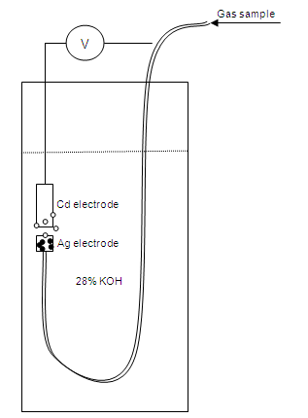

Oxygen is bubbled over a silver electrode where it is reduced. The electrochemical reaction is completed at the cadmium electrode, which is converted to cadmium(II) hydroxide. The oxygen concentration is proportional to the potential reading.

- Write an equation for the overall cell reaction. Given that E○(Cd(OH)₂|Cd) = −0.81 V, calculate the standard cell potential of the setup above.

- The system should be flushed with nitrogen or argon first before oxygen is bubbled in. Explain why.

- 10 dm³ of oxygen at 15 °C and 4 atm is pumped into the apparatus. What is the corresponding volume of oxygen at 298 K and 1 atm?

- Explain if the concentration of methane in a gaseous sample can be determined with the same method.

(v) To calculate the concentration of oxygen, Equation 1 is used. If a potential reading of 1.15 V is obtained, calculate the concentration of oxygen.
Equation 1:
[6]
(b) Equation 1 is derived from the Nernst equation, , where n is the number of moles of electrons transferred per mole of equation, R is the molar gas constant in J K^{–1} mol^{–1}, F is the Faraday constant in C mol^{–1} and Q is the reaction quotient. When E = 0, the system has achieved equilibrium.

An electrochemical cell is composed of two half-cells, namely the AgCl|Ag and Ag⁺|Ag half -cells.

AgCl(s) + e– Ag(s) + Cl– E○ = +0.22 V

(i) Write the overall equation for the cell reaction. Using the Data Booklet and the given E○ value, calculate the E○_{cell}.

(ii) Use the value in (b) (i) and the Nernst equation to calculate the solubility product of AgCl at 298 K.
[3]

(c) Manganese is a transition element that can exist in several oxidation states:
Manganese species | Mn²⁺ | MnO₄^{2–} | MnO₄⁻
Colour (in aqueous medium) | pale pink | green | purple

(i) Using manganese as an example, explain why transition elements can exhibit multiple oxidation states.

(ii) Explain why transition elements form compounds that are coloured.

(iii) With reference to the following data, and other relevant information from the Data Booklet, explain why an acidic solution of MnO₄^{2–} produces two different manganese containing species and state the observations of this reaction.

MnO₄²⁻ + 4H⁺ + 2e– MnO₂ + 2H₂O E○ = +2.26 V

(iv) Potassium manganate(VII) is commonly used as an oxidising agent in organic chemistry. Give the structural formulae of the organic product(s) from the following reactions.

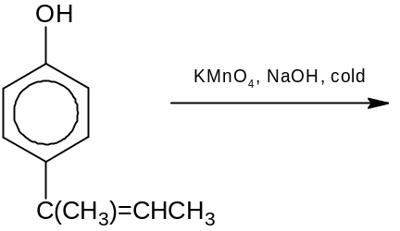 (I)

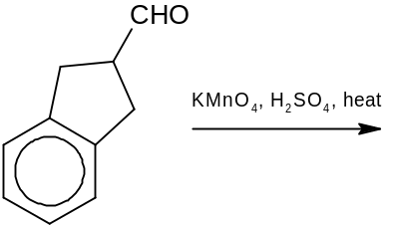 (II)

[11]
[Total: 20]
2 This question is on nucleophilic reactions.
(a) Hydroxyl compounds can react with acyl chlorides to form esters. An example is given below.

C₆H₅OH + CH₃CH₂COCl → CH₃CH₂COOC₆H₅ + HCl

(i) Identify the nucleophile in the reaction and hence explain why NaOH is used in the reaction.

(ii) Carboxylic acids can also act as the nucleophile in the reaction. Predict the product when (CH₃)₂CHCOOH reacts in the above reaction in replacement of the nucleophile identified in (a) (i).
[3]

(b) The reaction scheme below shows how an ester A can react to form butanone.
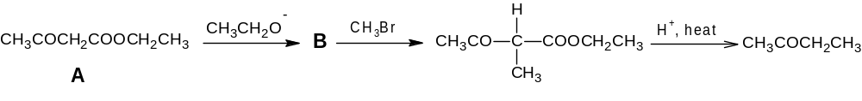

- Suggest the structural formula of B, and hence state the function of CH₃CH₂O– ions.

(ii) By means of a simple chemical test, propose a method to distinguish butanone from butan-1-ol. Write a chemical equation for the positive test.
[5]

(c) Butanone can also react with primary amines to give compounds called imines. The reaction scheme below illustrates this.

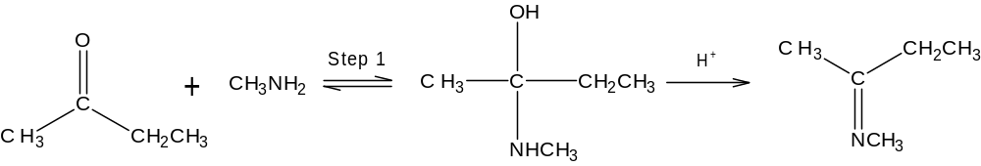
C

- Identify the mechanism in Step 1.

(ii) The final product C in the reaction scheme is able to exhibit stereoisomerism. State the type of stereoisomerism exhibited and draw all the stereoisomers of the product.
[4]

(d) The following table shows how the rate of the hydrolysis of 1-chlorobut-2-ene is affected when different concentrations of 1-chlorobut-2-ene and NaOH are used.

CH₃CH=CHCH₂Cl + NaOH → CH₃CH=CHCH₂OH + NaCl

Experiment | [CH₃CH=CHCH₂Cl]  / mol dm⁻³ | [NaOH]  / mol dm⁻³ | Relative Rate
1 | 0.1 | 0.1 | 1
2 | 0.2 | 0.1 | 2
3 | 0.3 | 0.3 | 3

- Determine the order of reaction with respect to each reactant, and hence describe the mechanism of the hydrolysis.

- Draw the energy profile diagram of the reaction.

(iii) Suggest a reason why CH₃CH₂CH=CHCl is inert towards hydrolysis.
[8]
[Total: 20]

3 (a) Scientists believe that the recent loss of ozone, O₃, from the upper atmosphere is due to reactions involving chlorofluorocarbons (CFCs) such as CF₃Cl, which undergo photolysis in the upper atmosphere according to the following reactions:

Reaction 1: CF₃Cl →•CF₃ + Cl•
Reaction 2: Cl• + O₃ → ClO• + O₂

The ClO• radical then reacts with oxygen species to produce Cl• radicals.

- Explain why the Cl• radical is formed instead of the F• radical in Reaction 1.

(ii) Compare the second ionisation energy of O and F and explain the difference.
[3]

(b) Halogenated organic compounds such as CFCs can be synthesised from various functional groups.

(i) Both alkenes and alcohols can react with hydrogen chloride gas to form halogenated compounds. State how hydrogen chloride gas can be synthesised from sodium chloride crystals. Explain why hydrogen iodide is less likely to be synthesised from sodium iodide crystals using the same method, and hence, suggest a suitable reagent to synthesise hydrogen iodide from sodium iodide.

(ii) 4-Chloromethylbenzene can be synthesised from the reaction of methylbenzene with chlorine under suitable conditions. State and describe the mechanism of this reaction.

(iii) Methylbenzene reacts with chlorine via a free radical substitution to form (chloromethyl)benzene. What condition is required for this?

(iv) For 2-methylbutane, the order of reactivity of tertiary, secondary and primary hydrogen atoms follows a 5:4:1 ratio. Draw all the monochlorinated products formed when 2-methylbutane reacts with chlorine and predict the ratio in which these products are formed.
[11]

(c) Sodium chlorate(I), NaClO, can be prepared in the laboratory by bubbling chlorine gas into cold aqueous NaOH.

Cl₂(g) + 2NaOH(aq) → NaCl(aq) + NaClO(aq) + H₂O(l)

The concentration of NaClO prepared can be determined by reacting it with excess acidified potassium iodide to form chloride ions and iodine as the products. The iodine liberated is then titrated against sodium thiosulfate solution, Na₂S₂O₃(aq).

It was found that 25.0 cm³ of the NaClO solution liberated enough iodine to require 50 cm³ of 0.100 mol dm⁻³ of sodium thiosulfate solution for complete reaction.

(i) State the type of reaction undergone when chlorine is bubbled into cold aqueous sodium hydroxide.

(ii) Write the equation of the reaction between ClO⁻ and iodide ions.

(iii) Hence, determine the concentration of the NaClO solution.

(iv) In a separate experiment, x cm³ of chlorine gas was bubbled into excess cold aqueous NaOH and completely reacted. If y cm³ of a 0.10 mol dm⁻³ AgNO₃ solution were required to precipitate all the chloride ions from the reaction, what volume of the same AgNO₃ solution would be required if x cm³ of chlorine gas was bubbled into excess hot aqueous NaOH instead?
[6]
[Total: 20]

4 Ammonia can be prepared from several methods.
(a) Hydrogen and nitrogen can react in the presence of a mixture of FeO and Al₂K₂O₄ under a variety of conditions as shown below.

FeO/Al₂K₂O₄
N₂(g) + 3H₂(g) 2NH₃(g) ∆H = –92 kJ mol^{–1}

Pressure / atm | Equilibrium concentration of NH₃(g) / % by volume
Pressure / atm | At T₁ | At 400 °C | At T₂
1 | 15.3 | 0.44 | 0.05
100 | 80.6 | 25.1 | 4.47
200 | 85.8 | 36.3 | 8.25

(i) Explain why the yield of NH₃ increases with pressure.

(ii) State which of the temperatures listed above has the highest value.

(iii) With the aid of a sketch of the Boltzmann distribution, explain the role of the FeO and Al₂K₂O₄ mixture.

(iv) A 1:3 mixture of N₂ and H₂ was reacted at 400 °C and 1 atm. Calculate K_{p} at this temperature.
[8]

(b) NH₃ can also be prepared by reacting a metal nitride such as Mg₃N₂ with H₂O, as summarised by the following equation:

Mg₃N₂(s) + 6H₂O(l) → 3Mg(OH)₂(s) + 2NH₃(g)

- Draw the dot-and-cross diagram of Mg(OH)₂.

(ii) Group II hydroxides decompose when heated to high temperatures. Write a general equation for this decomposition. State and explain the trend in the decomposition temperatures of the Group II hydroxides.
[5]

(c) NH₃ is also produced by the hydrolysis of primary amides.
(i) State the reagents and conditions required for the hydrolysis. Give the structural formula of the organic product when CH₃CH₂CONH₂ is hydrolysed.

(ii) Construct a 4−step reaction scheme to show how CH₃CH₂CONH₂ may be synthesised from CH₃CH₂Cl, showing the reagents and conditions used and the intermediates produced.
[7]
[Total: 20]

5 (a) The following questions are on Period 3 elements and their compounds.
(i) Describe and explain the trend in the melting points of the elements across Period 3.

(ii) The chlorides of aluminium and silicon react differently with water to produce acidic solutions. Explain why solutions of aluminium chloride and silicon chloride are acidic.

(iii) Aluminium oxide is amphoteric. With the aid of equations, explain the meaning of the term amphoteric.
[8]

(b) P (C₄H₁₀O₂) reacts with acidified potassium dichromate(VI) to give Q (C₄H₆O₃). Q produces effervescence when reacted with aqueous sodium carbonate. P and Q also react with aqueous alkaline iodine to produce a yellow precipitate R. Q reacts with NH₃ to produce S (C₄H₉O₃N). S reacts upon gentle warming with aqueous NaOH to produce an alkaline gas.

(i) Deduce the structures of P, Q, R and S.

(ii) P is unreactive towards aqueous sodium carbonate. Explain the difference in the reactivities between P and Q towards aqueous sodium carbonate.

(iii) 0.765 g of solid crystals of Q was added into a styrofoam cup containing 50 cm³ of 0.20 mol dm⁻³ aqueous sodium hydroxide. The mixture was thoroughly stirred and the temperature of the mixture rose by 1.8 ºC. Calculate the enthalpy change of neutralisation. Comment on this value, with reference to the enthalpy change of neutralisation between hydrochloric acid and sodium hydroxide.
[12]
[Total: 20]

END OF PAPER

